

**Faculty of Science**

**Software Engineering**

RESTURANT

Phase 2: Software Design Document

FLAVOUR HAVEN

Rofaida Ezzat 20221453055

May2024

Contents

Instructions [To be removed] 3

Team 3

Document Purpose and Audience 3

System Models 4

I. Class diagrams 4

I. Sequence diagrams 5

Class - Sequence Usage Table 7

III. Physical Entity-Relationship Diagram 7

IV. User Interface Design 8

V. Dataflow diagram (DFD) 9

VI. Algorithms and Data Structures 9

Ownership Report 10

Policy Regarding Plagiarism: 10

# Instructions [To be removed]

# Team

|  |  |  |  |
| --- | --- | --- | --- |
| **ID** | **Name** | **Email** | **Mobile** |
| 20221453082 | مريم السيد محمد | sci.MaryamElsayed53082@alexu.edu.eg | 01273603151 |
| 20221453055 | رفيدة عزت منصور | sci.RofaidaEzzat3055@alexu.edu.eg | 01223050957 |
| 20221456510 | روان محمد حسن | Sci.RawanMohamed56510@alexu.edu.eg | 01200990652 |

# Document Purpose and Audience

Purpose of this document will explain interaction model by sequences model and interaction model

**List the target audience to read this document The interaction model is typically used by designers, engineers, and developers to understand how users interact with a system or product. The structural model, on the other hand, is more commonly utilized by architects, engineers, and designers to comprehend the underlying framework or composition of a system or product. Both models are essential for creating effective and user-friendly designs.**

# System Models

## Class diagrams

**List down your classes and describe them**

| **Class ID** | **Class Name** | **Subsystem ID** | **Description & Responsibility** |
| --- | --- | --- | --- |
| 1 | user | User management  1 | Update profile() |
| 2 | customer | user management  1 | Register(login password),add payment |
| 3 | admin | user management  1 | Manage menu item |
| 4 | User interface | User interface  2 | Login, browse menu |
| 5 | Backend server | Back end processing  3 | Update menu |
| 6 | order | Order management  4 | Add item()remove item() |
| 7 | Payment gateway | Payment processing  5 | Verify payment |
| 8 | database | Data management  6 | Store order& store payment transaction |

## Sequence diagrams

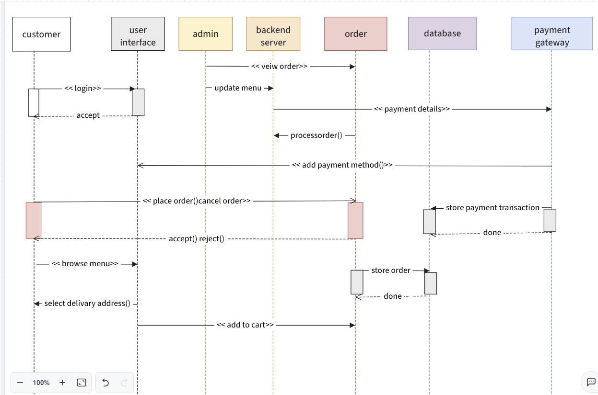

### Class - Sequence Usage Table

| **Class Name** | **Sequence Diagrams** | **Overall used methods** |
| --- | --- | --- |
| customer | 4,6 | Registration(login), place order() , cancel order |
| User interface | 6 | Add cart() |
| admin | 5,6 | View order() , update menu() |
| Backing server | 7 | Payment details() |
| order | 5,8 | Store order() |
| Database | 7 |  |
| Payment gateway | 4,8 | Store payment transaction,  Add payment method() |

## III.Physical Entity-Relationship Diagram

**صورة تحتوي على لقطة شاشة, نص, التصميم

تم إنشاء الوصف تلقائياً**

## IV. User Interface Design

صورة تحتوي على نص, لقطة شاشة, التصميم

تم إنشاء الوصف تلقائياً

صورة تحتوي على الخضروات, نص, المجموعة الغذائية, سلطة

تم إنشاء الوصف تلقائياً

## V. Dataflow diagram (DFD)

+-------------------+

| User Interface |

+---------+---------+

|

v

+-------------------+

| Backend Server |

+---------+---------+

|

+---------+---------+

| |

v v

+-------------------+ +-------------------+

| Database | | Payment Gateway |

+---------+---------+ +---------+---------+

| |

+-------------------------+

|

+------------+------------+

| |

v v

+----------------+ +----------------+

| User | | Admin |

| Customer | +----------------+

+----------------+

| Order |

+----------------+

## VI. Algorithms and Data Structures

# صورة تحتوي على نص, ورقة ملاحظة لاصقة, رسم بياني, خط يد تم إنشاء الوصف تلقائياً

# صورة تحتوي على رسم بياني, لقطة شاشة, نص, خط تم إنشاء الوصف تلقائياً

صورة تحتوي على نص, لقطة شاشة, رسم بياني, التصميم

تم إنشاء الوصف تلقائياً

صورة تحتوي على نص, لقطة شاشة, ورقة ملاحظة لاصقة, رسم بياني

تم إنشاء الوصف تلقائياً

**Pseudo code to calculate salary for team:-**

total_salary = 0

for each team_member in team

salary = team_member.hourly_rate * team_member.hours_worke

total_salary += salary

print("Total salary for the team:", total_salary)

**Pseudo code to calculate how much the customer will pay:-**

1. Initialize total_amount = 0

2. Loop:

a. Display menu to the customer

b. Customer selects an item

c. Get the price of the selected item

d. Add the price to total_amount

3. If the customer wants to add more items:

- Repeat the loop

4. If the customer is done ordering:

- Display the total_amount to the customer

- Ask for any additional charges (tax, tip, etc.) and add them to total_amount

- Display the final total_amount to the customer

# Ownership Report

* **Remove the following notes and any red notes**
* **For every item in this document, write the owners. If someone is owner of something, s/he understands it 100.%**
* **Team leader must verify the table with the team members.**

|  |  |
| --- | --- |
| **Item** | **Owners** |
|  |  |
|  |  |

# Policy Regarding Plagiarism:

**Students have collective ownership and responsibility of their project. Any violation of academic honesty will have severe consequences and punishment for ALL team members.**